The Clintonville-Beechwold Community Resources Center
3222 N. High St. Columbus, OH 43202
Ph: 614-268-3539 Fax:614-268-5028
https://vinville.clubexpress.com
Village in the Ville Volunteer Application
Village in the Ville could not do what we do without your skills, talents, compassion, dedication, and commitment. Please know how much we value these gifts, and how excited we are to see them come to life through the many programs, services, and opportunities we offer.

Date:______________
Applicant

Last Name:_________________________ First Name:____________________

Address:___________________________ City:_________________________ Zip:___________

Email:_____________________________ Phone:_________________________________________

Date of Birth: _______________________

Preferred method of contact: _________________________________

If you are a student

Name of School_________________________ Field of Study__________________________

Emergency Contact

Contact Name:_________________________________________________________________

Contact Phone:___________________________ Relationship to You_____________________

Volunteer Opportunities (Check all areas of interest)

⃝ Driver
⃝ Friendly Visit
⃝ Friendly Calls
⃝ Computer Assistance
⃝ Yard/Snow Maintenance
⃝ Fundraising
⃝ Reading Aloud

⃝ Medical Companion / Advocate
⃝ Pet Care
⃝ Run Errands
⃝ Gardening
⃝ Member Birthday Program
⃝ Community Outreach

⃝ Event Coordination
⃝ Record Keeping
⃝ Minor Home Maintenance
⃝ Office Support
⃝ Board Member/Committee Member
⃝ Other____________________

Is it okay to send email announcements about Village in the Ville activities to this address? ⃝ Yes ⃝ No

Previous Experience
Organization | Dates | Services Provided

References (Please list someone not related to you):

- Name____________________________ Phone Number__________________

Email Address__________________________

- Name____________________________ Phone Number__________________

Email Address__________________________

Availability-Please list the hours you are available 8am-12pm

Sunday ________________ Monday _______________ Tuesday______________
Wednesday ____________ Thursday_______________ Friday________________
Saturday_______________
I may be occasionally be available outside regular hours: YES NO

By signing this application, I verify that the information provided is true, correct, and complete. I hereby give my consent to The Clintonville-Beechwold Community Resources Center (CRC) to verify this information, including contacting references, and unconditionally release CRC from all liability which might result from furnishing same. I understand that my acceptance as a volunteer is on a conditional basis, and that CRC reserves the right to terminate the service of any volunteer whose conduct and preference in any way reflects negatively upon the agency.

_____________________________________ ___________________
Applicant Signature Date

⃝ Optional-check if “yes”; I grant full permission to the sponsors, organizers, and affiliates to use my name or my child’s name, photographs, or any other record of participation in this volunteer service event for use in any broadcast, telecast, or any other written account of the event for publicity purposes, without compensation or remuneration.

If applicant is under 18: I give my permission for my child to participate as a volunteer with CRC. I understand that CRC staff are not responsible for the care of supervision of my child and I will not hold CRC responsible if my child leaves the premises.
__________________________________ ______________________
Parent/Guardian Signature Date
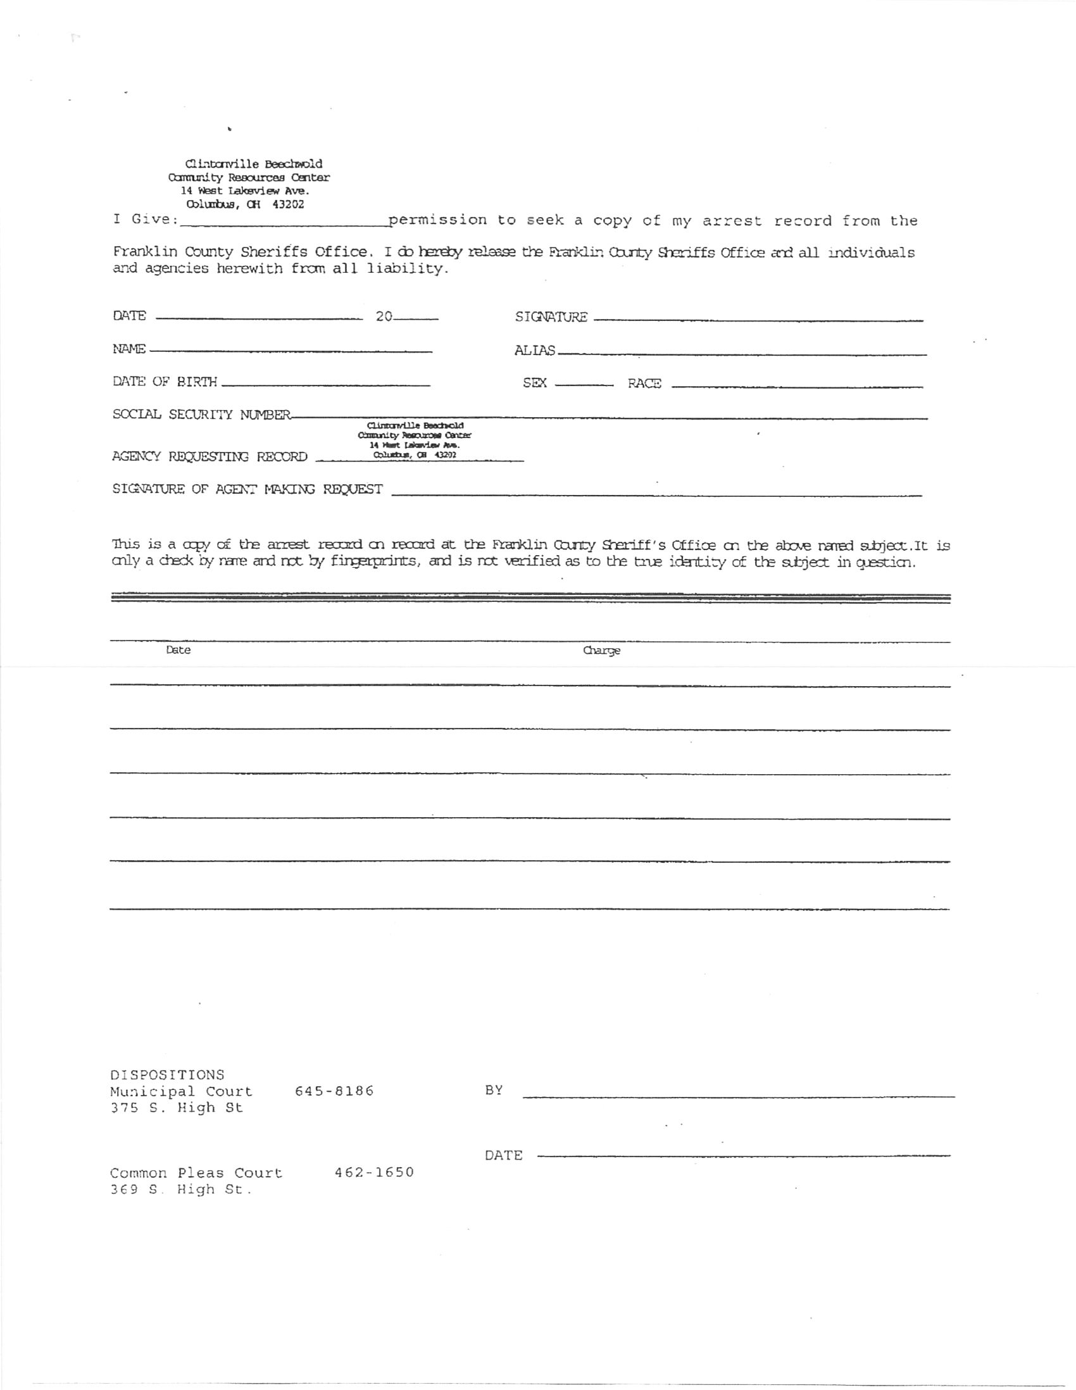

The Clintonville-Beechwold Community Resources Center
3222 N. High St.
Columbus, OH 43202
Voice: 614-268-3539 Fax: 614-268-5028
www.clitonvillecrc.org

Volunteer Statement of Confidentiality
During the time you spend at the CRC or any of its programs or events you may see someone you know who lives in your neighborhood or attends your school, church, or place of employment. It is very important that you respect that person’s privacy and legal rights to keep their information private. Even telling someone that you saw your neighbor, colleague, etc. at the CRC is breaking the law.

There are in effect federal and state regulations, legal precedents and social work codes of ethics that prohibit disclosure of any information obtained from a client in confidence, including the client’s presence and/or status of receiving services without the client’s written consent, except when disclosure is necessary to prevent serious, foreseeable and imminent harm to the client or another identifiable person. In other words, as a CRC volunteer you are required to maintain confidentiality unless you believe a client may harm him/herself, harm another identifiable person, or a child is being harmed. In these cases, you are a mandated reporter and as such have an obligation to report the situation to the supervisory staff person on duty.

These regulations and ethical codes were designed to ensure the privacy of any individual seeking services. It is not appropriate to talk about who is receiving benefits, share information or photos in any way including on the internet and social media. Confidentiality includes the client’s presence and/or status of receiving services. Confidentiality includes the safeguarding of client records. Volunteers and staff are responsible for the confidential handling of all information that we receive from our clients. Volunteers and staff are responsible to ensure that records are secured in a locked environment at all times. Any volunteer or staff person who violates these regulations may be held legally responsible.

I signify that I have read and am willing to comply with the above statement.

_______________________________________________ _____/_____/_____
Signature Date

